1. Problem 1a: Assume that a and b are integers with a ≤ b, and that S and T are sequences
on . Explain why
$$\sum_{i=a}^{b}{S_{i}}+\sum_{i=a}^{b}{T_{i}}=\sum_{i=a}^{b}{(S_{i}}+T_{i})$$

2. Problem 5: Suppose that a and b are integers with 0 ≤ a ≤ b – 4.
a. How many elements are there in {a … b}?
b. How many 4-sequences on {a … b} are there?
c. How many 4-permutations on {a … b} are there?
d. How many increasing 4-sequences on {a … b} are there?

3. Problem 7: Passwords on a certain system have exactly 5 letters that are either lowercase letters or
uppercase letters.
a. How many possible passwords are there?
b. How many possible passwords are there that use only lowercase letters?
c. How many possible passwords are there that use only uppercase letters?
d. How many passwords are there that use at least one uppercase letter and at least one
lowercase letter?
4. Problem 9: A personal identification pin may be set to any 4 digits.
a. How many possible PINs are possible?
b. How many PINs are there that do not have a repeated digit?
c. How many PINs are there that do have a repeated digit?

5. Problem 10: Suppose that in a certain jurisdiction, license plates have 4 letters followed by 3
digits, and that all such character sequences are possible.
a. Show that the number of license plates that have exactly two T’s and end in 5 is
375,000.
b. Show that the number of license plates that have the letter T and the digit 4
(someplace) in them is 17,981,121.

6. We discussed that the Cartesian Plane (the x-y plane) is actually the Cartesian product of  with itself
( cross ). Draw a picture of each of the following three Cartesian products:
    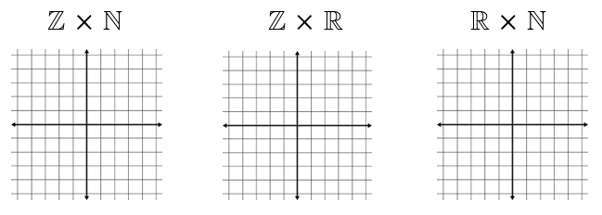    
                         

7. Use a systemic counting method (not a formula) to determine how many distinct triangles
are identifiable in the diagram below.

